HARDWARE

Components

Power Supply
- Battery
- H-Bridge
- CPT 15W DC/DC Converter

Sensors
- KS103 Ultrasound Sensor
- Camera

Control
- DE0-Nano Board
- Raspberry Pi 3

Actuators
- Steering Servo Motor
- Drive Motors
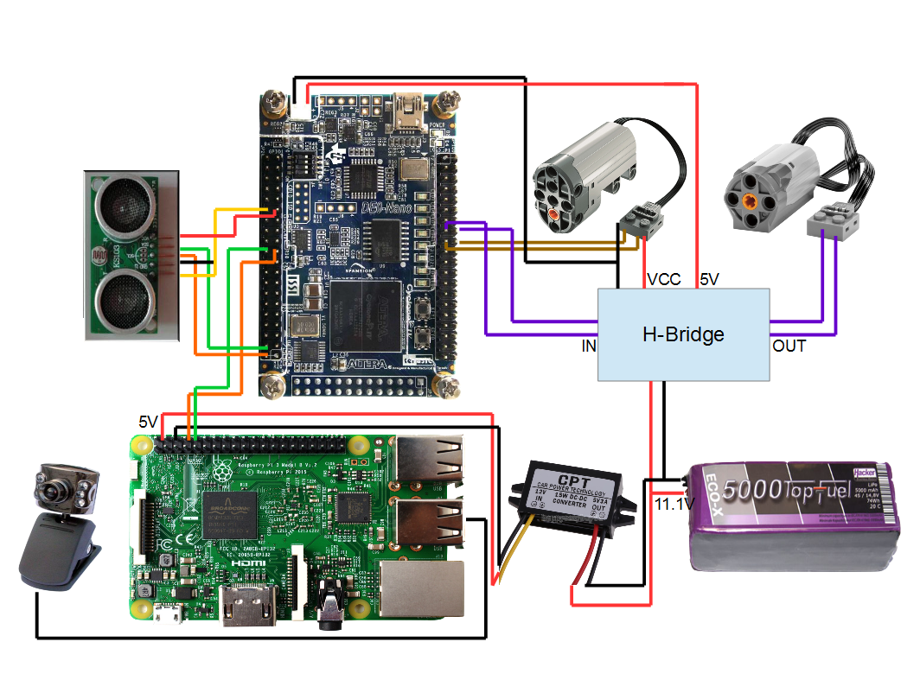
Power Supply

As a battery, we've used “eco-x 5000 Top Fuel” battery, which provides 11.1V energy. An H-Bridge is used to convert from battery comming current to 5V because the Nano Board works at 5V. We've also used a DC/DC converter which is an electronic circuit that converts from the battery coming voltage to 5V, so that we can use the 5V pins of the Raspberry Pi.

How to Connect

- Connect the 11.1V red cable of the battery with the VCC input of the H-Bridge. The black GND cable has to be connected with the GND input of the H-Bridge.

- The 5V Output of the H-Bridge has to be connected with the 5V input of the Nano Board. Then connect the GND input of the H-Bridge with the GND input of the Nano Board.

- Connect the red cable of the DC/DC converter with the red cable of the battery and the black cable with the black one of the battery.

- Connect the servo motor's 11.1V input with the VCC input of the H-Bridge. GND input of the servo motor has to be connected with the GND input of the H-Bridge. From the H-Bridge going GND cable splits in two wirings. While one of them is connected to servo motor the other one is connected with the Nano Board.

Sensors

A simple web cam camera and “KS103 Ultrasound Sensor” are used as sensors. The camera is used for the line detection. The ultrasound sensor is used to detect an obstacle. The closer is the obstacle, the slower is the speed of our car.

The KS103 Ultrasound Module has 5 pins:
- VCC: power pin
- SDA/TX: data pin
- SCL/RX: clock pin
- GND: power ground pin
- Mode: selects the communication mode

There are two options for the communication: UART (universal asynchronous receiver/transmitter) and I²C. We've used the UART modus in this project, which is an asynchronous serial communication format.

How to Connect

- Connect the 5V VCC and GND pins of the sensor with the 5V and GND pins of the Nano Board.

- The Mode pin has to be connected with the GND pin of the Nano Board.

- Connect the TX and RX inputs with the UART output of the Nano Board. GPIO_00 is connected with the TX pin and GPIO_01 with the RX pin.

- Connect the camera with one of the USB-ports of the Pi.

Control

We've used the “DE0-Nano Board” to provide an interface for the “Raspberry Pi 3” to control the car. The DE0-Nano Board introduces a compact-sized FPGA development platform suited for portable design projects, such as robots and mobile projects. The UART is used as the communication method between these two components.

How to Connect

- Connect the UART pins of the Pi with the UART pins of the Nano Board. 8th pin of the Pi is the TX and 10th pin is the RX pin. In this project they are connected to GPIO_016 and GPIO_017 of the Nano Board.

- The 2nd and 4th pins are the 5V pins of the Pi. Choose one of them and connect it with the the DC/DC converter. The 6th pin is the GND pin and it has to be connected with the GND cable of the DC/DC converter.

Motors

We have two driving motors and one servo motor on our car. The servo is used for the steering and the two driving motors are used to move the car. We've used PWM(Puls-width modulation) which is a modulation technique used to turn a message into a pulsing signal. By using this modulation we had the abilty to arrange the speed of our car and also the steering angle.

How to Connect

- Connect the driving motor with the respective outputs (OUT3 and OUT4 in this project) of the H-Bridge. This will provide the driving. If the car doesn't drive in the direction you want, then you should switch the wirings.

- Connect the PWM output of the Nano Board (GPIO_112 and GPIO_113 in this project) with the PWM input (IN3 and IN4 in this project) of the H-Bridge.

- Connect the two remaining cables of the servo motor with the PWM output (GPIO_114 and GPIO_115 in this project) of the Nano Board. This will provide the steering.

WICHTIG!!! Ich bin mir nicht ganz sicher, ob ich richtig gemacht habe, wo ich GPIO_1xy und GPIO_0xy geschrieben habe. Diese 0/1 hängen davon ab, ob wir die linke seite oder rechte seite der Board verwendet haben. Kontrolle bitte nur eine, was ich oben gemacht habe. Entweder alles ist in ordnung oder alles soll umgekehrt sein.

